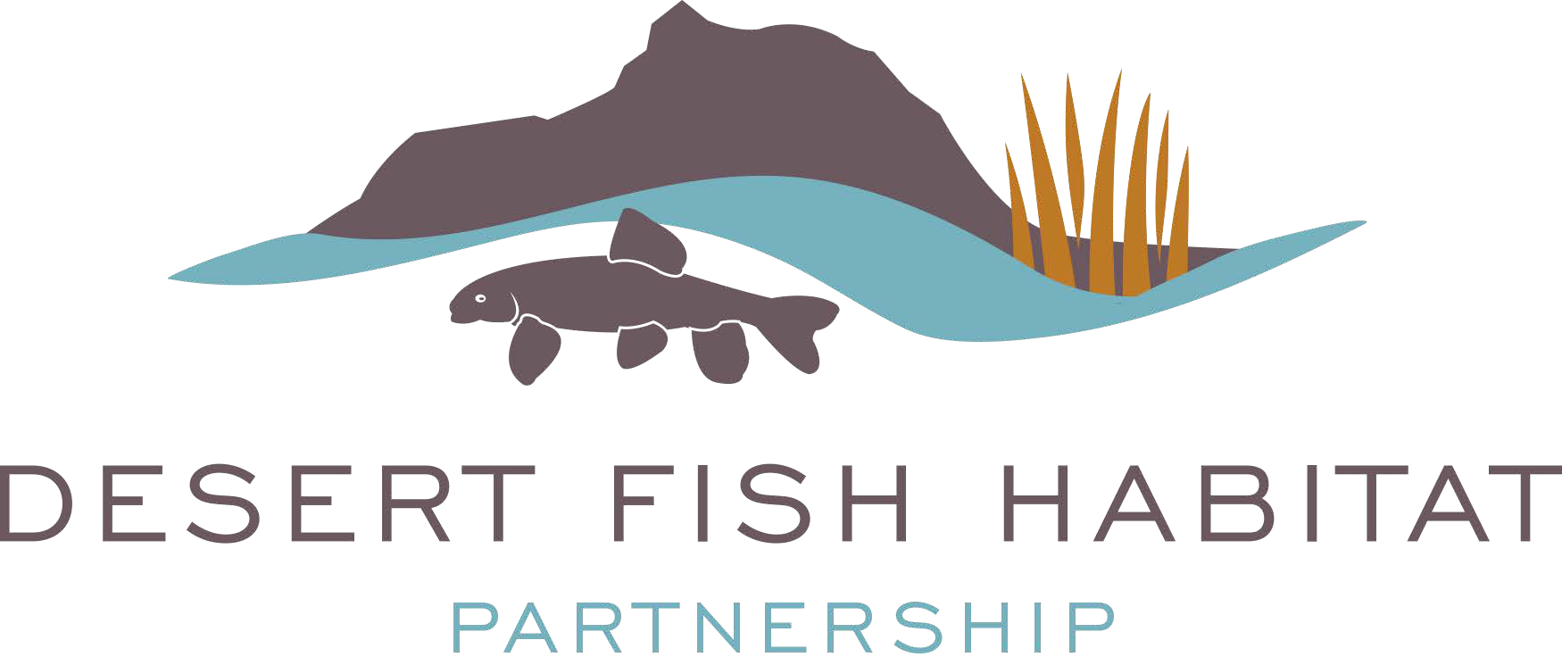

Desert Fish Habitat Partnership Proposal Evaluation and Criteria Form

DFHP Regional Workgroups and Executive and Steering Committees will consider the following factors in selecting projects for funding:

 | DFHP Evaluation Criteria | Maximum  Points
1. | DFHP Habitat and Species Addressed  - Does the proposed project address an identified DFHP Habitat  (pg. 2 Strategic Framework)?  - Are DFHP species identified with ranks? Are multiple species involved? (pg. 26 Strategic Framework)  - Is the project in the prioritized DFHP sub-region for this year? | 15
2. | Project Objectives and Measurable Outcomes  - Does the proposal align with DFHP’s principal goals (pg. 10 Strategic Framework)?  - Does the proposal fit into larger conservation efforts, such as the DFHP Strategic Plan, state wildlife action plans, multi- species conservation plans, habitat conservation plans, recovery plans, or other local plans?  - Does the proposal align with NFHP’s National Conservation Priorities? | 15
3. | Technical Merit  - Is the proposal supported by sound and established scientific, hydrological and biological studies or principles?  - Will the project enhance or sustain species diversity, increase populations of target species, and maintain or increase aquatic ecosystem function?  - Does the project have a high likelihood of providing long-term benefits for DFHP priority species and habitats?  - Does the project applicant and partners have sufficient technical qualifications to complete the project? | 15
4. | Proposal Format  - Did the project applicant provide all of the information required  in the RFP and in the proper format? | 5
5. | Partnerships/Community Support  - Does the project have multiple and diverse partners working in collaboration?  - Are there letters of support or signed documentation from approving officials, including the appropriate State Department, and/or affected landowners stating their commitment to the proposed project?  - Does the project have a high probability of being completed in  the next 2 years if it is funded? | 15

6. | Environmental and Regulatory Compliance (e.g., ESA, NEPA, 404 permits, or other permits as required)  - Has project applicant demonstrated adequate planning to ensure project implementation and completion?  - Which NEPA, 404, NHPA, Section 7 or other state and federal permits are needed to execute the project, and have they been acquired? If not, when will they be filed and obtained? (Projects with completed NEPA/state permits will receive higher priority). | 10
7. | Monitoring and Best Management Practices  - Does the proposal include a monitoring plan with clear objectives for evaluating the success and goals of the project?  - Does the monitoring plan include both pre- and post-project monitoring activities?  - Does the monitoring plan include adaptive management strategies if monitoring shows project is not meeting stated goals and objectives?  - Do the Best Management Practices or conservation actions proposed include a description and timeline of the long-term maintenance responsibilities that assure the project will be successful and the results sustainable? | 10
8. | Budget  - Are cost estimates appropriate, focused on actions linked to DFHP objectives, well justified, and reasonable?  - Does the project leverage other government or private funding or in-kind resources that meet a 1 federal: 1 non- federal cost share?  - Is partner funding and/or resources an important element for project implementation?  - Does the project link to or add value to another existing or future conservation efforts? | 10
9. | Education and Outreach  - Does the proposal have a viable and effective public outreach component?  - Does the project have great potential to foster/generate a conservation ethic through citizen/youth involvement?  - What form will outreach take? Examples: Internet website, social media, newspapers, interviews, etc.  - Are there plans to develop on-site informational signs? | 5
 | TOTAL SCORE | 100

Scores for each of the nine criteria can range from the maximum to the minimum possible points using the following scale:
- 71 – 100% of the possible points for an exceptional response in which the project applicant gives evaluators the information they need and is clear and concise with documented support
- 46 – 70% of the possible points for a well-supported response
- 21 – 45% of the possible points for a minimally relevant response
- 0 – 20% of the possible points for little or no relevant response

